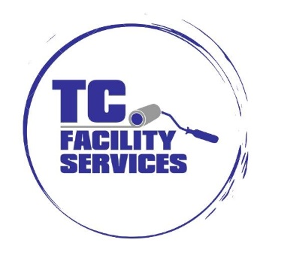

CREW MEMBER
Looking for a company you can grow with? TC Facility Services (an industrial/commercial cleaning and coatings company) is looking for AMAZING commercial painters and floor coating rock stars!

We are a full-service commercial and industrial cleaning, coating and painting company for small and large companies alike! TC Facility Services (formerly Trans-Clean 1981-2008) has been in business since 2008. Our professional crews have years of hands-on experience with a wide scale of projects, from manufacturing plants to municipalities, warehouses, and showrooms.

We believe a business is only as effective as its people, which is why we have so many long-term employees. Many of our supervisors and painters have been with the company for over 10 years.
​
RESPONSIBILITIES

The Crew member’s primary role is to apply industrial paint and perform relevant cleaning services.

- Apply all finishes in accordance with company policies.
- Ability to Setup and Operate all Equipment (i.e. Grinders, Floor Scrubbers, Generators, Air Compressors, Aerial Lifts).
- Ensure proper clean up at the end of each day. This includes picking up any materials that are unused, securing all tools, and setting up flagging to protect the job site. Cleaning out van when returned to shop.

QUALIFICATIONS
- High School Diploma/GED.
- 1 year painting and/or floor coating experience.
- Ability to work from ladders and aerial work platforms.
- Ability to read, comprehend and follow verbal instructions in English to perform the duties of this job in a safe and effective manner for the successful operation of the business.
- Ability to work well with others and always maintain professional conduct.
- Ability to take direction and willingness to learn.
We offer a competitive benefit and compensation package that includes health, dental, vision, 201(k) with company match, paid holidays, and PTO.

INTENT AND FUNCTION OF POSITION DESCRIPTIONS
This Position Description presents only essential functions and basic duties of the role. Other tasks, only incidentally related to the role are excluded. Requirements, skills, and abilities included have been determined to be the minimal standards required to successfully perform the role. In no instance, however, should the duties, responsibilities, and requirements described be interpreted as all inclusive. Additional functions and requirements may be assigned by management as deemed appropriate.

In accordance with the Americans with Disabilities Act, it is possible that requirements may be modified to reasonably accommodate disabled individuals. However, no accommodation will be made which may pose serious health or safety risks to the employee or others or which impose undue hardships on the organization. This position description is not intended to and does not create an employment contract. TC Facility Services, Inc. maintains its status as an at-will employer. Employees can be terminated for any reason not prohibited by law.

TC Facility Services is an Equal Employment Opportunity/Affirmative Action Employer that recruits qualified applicants and advances in employment without regard to race, color, religion, age, gender, gender identity, gender expression, sexual orientation, ethnic or national origin, genetic information, disability, marital status, veteran status or any other status protected by applicable federal, state, or local laws. O&G Industries also prohibits harassment and/or retaliation of applicants and employees based on any of these protected categories.

We are an E-Verify Participating Employer.

